**Idea Generation**

If you’re sitting down to write a business plan because you have a great idea, now’s the good time to give it a test run. Use these questions to begin to evaluate whether the idea you’re excited about can turn a profit.

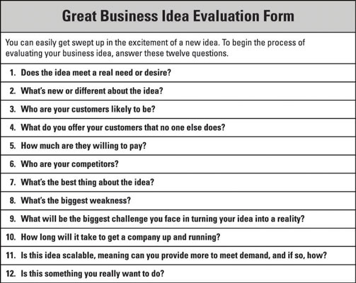Please complete the checklist of questions below before proceeding further.

DriveCare: The Smart Car Companion

Student 1: Chen Jing Heng B2100202

Student 2: Yap Fong Kiat B2100346

1. Does the idea meet a real need or desire?

Yes, it meets a real need. Many car owners, especially those who are not mechanically inclined, feel overwhelmed even will be scam by maintenance. They need a simple, centralized way to track their car's health, get reliable advice, and find trusted service providers. The desire is for convenience, peace of mind, and empowerment.

2. What's new or different about the idea?

The core differentiation is the integration of advanced AI. While some apps track service history or book appointments, none combine all three key features in a single, seamless platform:

* AI-powered visual recognition for both car registration and diagnostics (e.g., analyzing engine oil via an image).
* A personalized, AI-driven Q&A chat tailored to a specific car model.
* A fully integrated ecosystem for service tracking, booking, and proactive reminders.

3. Who are your customers likely to be?

* **Primary Customers:** Tech-savvy car owners, especially those aged 25-45, who are comfortable with mobile apps and want a modern solution for a traditional problem. This includes single professionals, young families, and individuals who value convenience.
* **Secondary Customers:** Car enthusiasts who want a detailed, digital log of their vehicle's history, and new car owners who need guidance on maintenance.
* **Other Customers:** Customers they don’t have idea about the car, can through this to understand how the problem about the car is, and make them have some concept

4. What do you offer your customers that no one else does?

The unique value proposition is the intelligent, integrated experience. We offer a personalized AI companion that not only answers questions but also provides visual diagnostics. This is combined with a seamless, end-to-end service management system, provide customer more conform system and they can from a simple photo of the car to a booked appointment at a nearby workshop, all within one application.

5. How much are they willing to pay?

Customers are likely willing to pay for convenience and peace of mind.

* Commission Model: They wouldn't pay directly for the app itself, but our business partners (workshops) would pay a commission on each booked service.
* Freemium Model: A premium subscription could be offered for advanced features (e.g., unlimited AI consultations, detailed maintenance analytics) at a small monthly fee, likely in the range of RM10 - RM20.

6. Who are your competitors?

* Direct Competitors: Other car maintenance and service booking apps (e.g., Perodua U first, specific workshop chain apps). However, they typically lack the AI diagnostic and image recognition features.
* Indirect Competitors: General online forums and car-specific websites (e.g., car forums, YouTube channels) where users seek information. These are unorganized and not personalized.

7. What's the best thing about the idea?

The fusion of practicality and cutting-edge technology. The idea solves a genuine, widespread problem by using AI in a highly intuitive way, creating a "smart companion" feel rather than just a simple utility app. It also help people can easily to know how the problem of car and what is the problem of the car through the car problem to understand their own car. The novelty of image-based diagnostics with the information of the car is a major selling point.

8. What's the biggest weakness?

The reliability and accuracy of the AI. Providing incorrect diagnostic information could be dangerous or lead to user frustration. Building and training a robust AI model for a wide range of car makes and models is a significant technical and resource-intensive challenge.

9. What will be the biggest challenge you face in turning your idea into a reality?

* Technical Development: The primary challenge is developing and training a reliable AI model for both image recognition and conversational diagnostics. This requires expertise and a large, high-quality dataset.
* Partner Onboarding: Convincing a critical mass of reputable workshops to join the platform and integrate their booking systems will be crucial for the service booking feature to be valuable to users.

10. How long will it take to get a company up and running?

* Phase 1 (MVP - Minimum Viable Product): 6-12 months to build and launch a basic version with manual entry and invite mass of reputable workshops to join the platform AI chat for a few car models, and a simple service booking function.
* Phase 2 (Growth): 1-2 years to fully develop the advanced AI features, expand the partner network, and refine the user experience based on feedback.

11. Is this idea scalable, meaning can you provide more to meet demand, and if so, how?

Yes, it is highly scalable.

* Technology: The AI models can be trained on more data to handle a wider range of car models and issues. The app infrastructure can be hosted on a cloud service that can scale to accommodate millions of users.
* Market: The business can easily be expanded to cover more geographical regions and partner with more service centers without significant changes to the core technology.

12. Is this something you really want to do?

Yes, I believe this will help people to easily take care of their car and also can help saving money by long term use. Periodic car maintenance is necessary to let the car have a longer life spend and this can indirectly reduce creating waste.